

# **Solution Test Bench – Dirty Device Plugin User guide**

Contents

**Solution Test Bench – Dirty Device Plugin User guide** 0

Add Digital Send Output Destination Server to STB 2

Add Output Configuration for Digital Send jobs 4

Configuring the Dirty Device Plugin 9

The DirtyDevice plugin can be configured to send digital send jobs as part of it’s test workflow. As such, an output location must be configured before running the test. This following steps define the process of adding an output destination server that will host the output location, then adding configuration for an output location path.

# Add Digital Send Output Destination Server to STB

This section explains how to add an infrastructure server to the STB configuration information. This list of servers is public to the entire system and can be used by other plugins. For the purposes of the DirtyDevice plugin, the server can be the same machine as your STB client or STB server.

1. Launch Solution Test Bench User Console from  > Solution Test Bench >STB User Console (OR)  [C:\VirtualResource\Distribution\STBUserConsole\SolutionTestBench.exe](../../../VirtualResource/Distribution/STBUserConsole/SolutionTestBench.exe)
2. On the top menu of STB, click on Configuration, then on Infrastructure Servers:

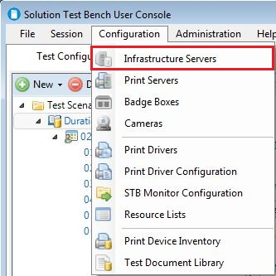

1. You should see the following Form. Click on “Add” in the upper right corner:

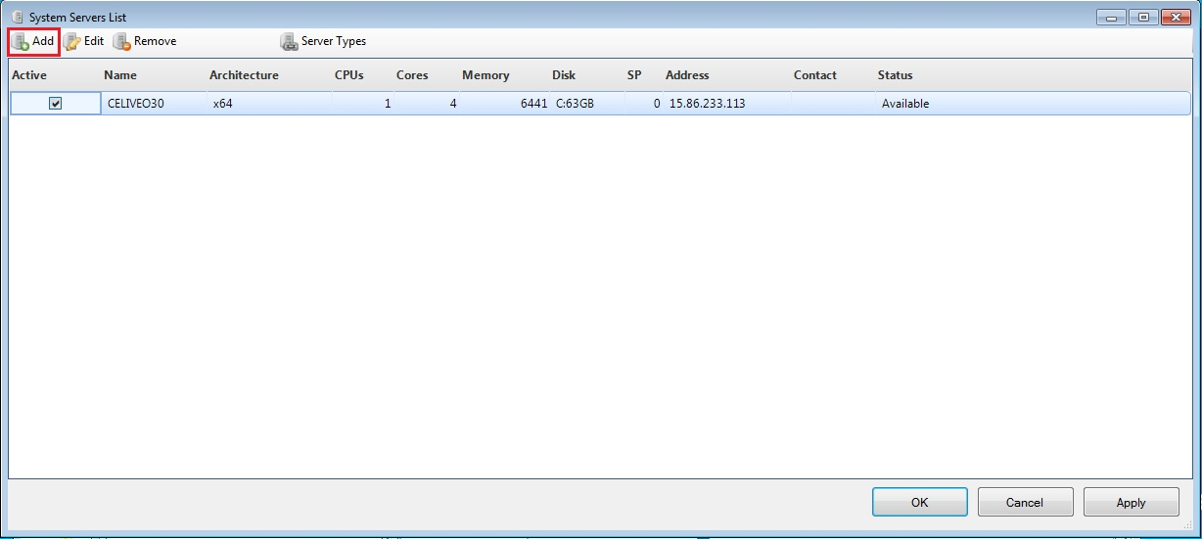

1. Enter the host name of the server that will be the location of your digital send output. Click **OK**.

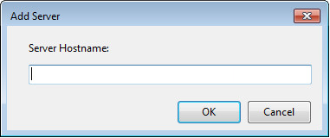

1. The software retrieves basic statistical information about the server and presents it in the following form. Make sure the Server Attributes are selected as shown. Click **OK**.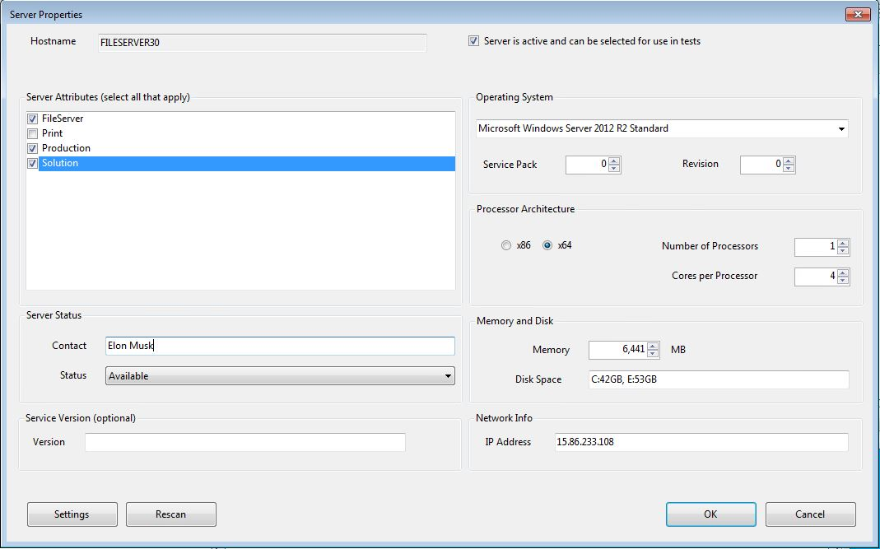
2. The server is now added to STB. Click **OK** to close the form.

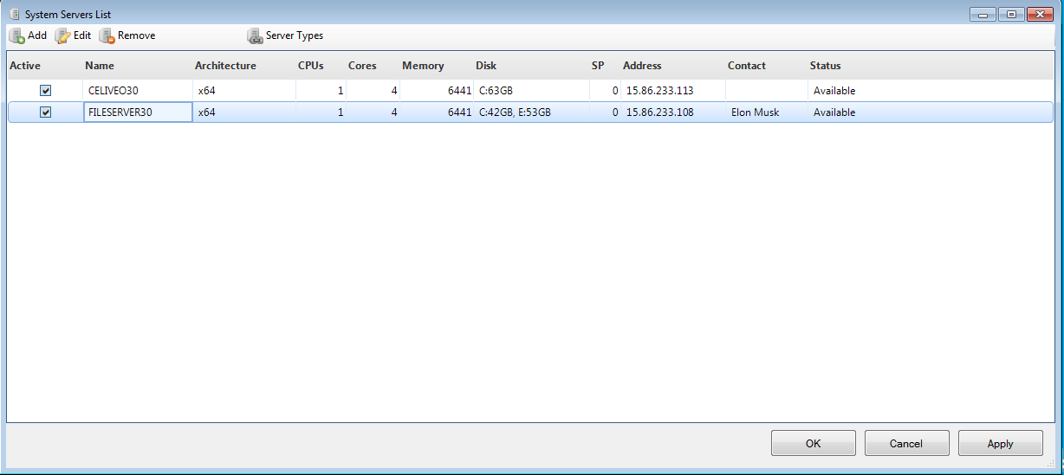

# Add Output Configuration for Digital Send jobs

Now that the output server has been added to the system, an output location setting can be added. This allows multiple tests to utilize the same output location. Once the server and the location have been entered, the configuration is public to other tests and can be utilized.

1. Launch Solution Test Bench User Console from  > Solution Test Bench >STB User Console (OR)  [C:\VirtualResource\Distribution\STBUserConsole\SolutionTestBench.exe](../../../VirtualResource/Distribution/STBUserConsole/SolutionTestBench.exe)
2. On the top menu of STB, click on Configuration, then on Infrastructure Servers: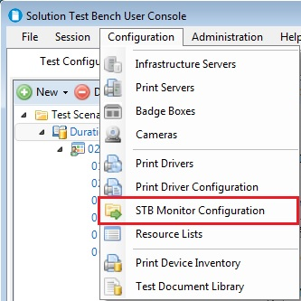
3. You should see the following Form. Click on “Add” in the upper right corner:

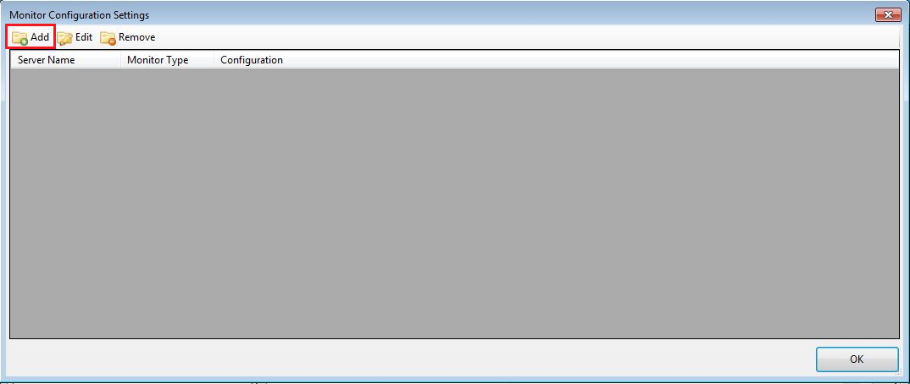

1. Choose the host that was entered in the previous section.

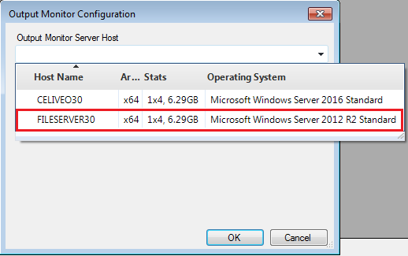

1. Choose **Output Directory** as the Monitor Type.

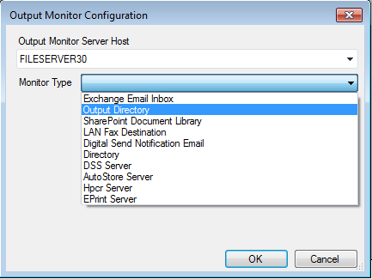

1. Once the Monitor Type has been selected, the remaining configuration interface will populate. The **Output Destination** is the final piece of configuration information that is needed for the Dirty Device Plugin. Do not include a drive letter in the Output Destination. A drive letter will cause the execution to fail. The Dirty Device Plugin builds the output path by combining the Server Host name and the Output Destination. For example, in the screenshot below the output path built by the plugin would be: \\FILESERVER30\STBOutput\DigitalSendJobs.

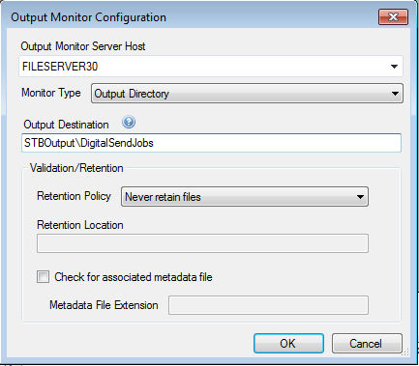

Hover your mouse over the help icon  for an example of a valid Output Destination for the Dirty Device Plugin.

1. When you tab off of the Output Destination text box, the software will attempt to validate the path you have entered. If the path you have entered does not exist on the Server Host, or if it is not publicly shared, you will see an error notification:

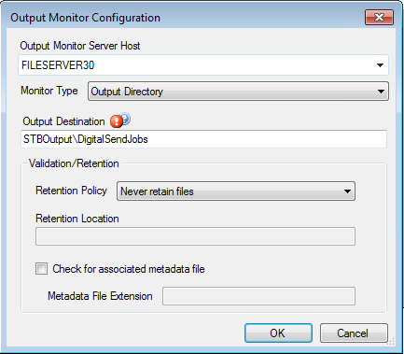

Hover over the error icon to view a specific message.

Also note that the Validation Retention section is not used by the Dirty Device plugin. The configuration form will accept Retention configuration, but the settings will be ignored by the Dirty Device Plugin. Once the Output Destination validates, click **OK**.

1. The Output Configuration is now added to STB. Click **OK** to close the form.

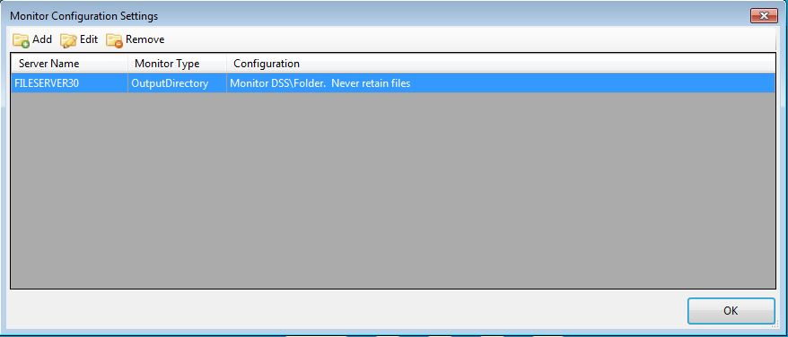

# Configuring the Dirty Device Plugin

1. Add a new Solution Tester to your existing Scenario:

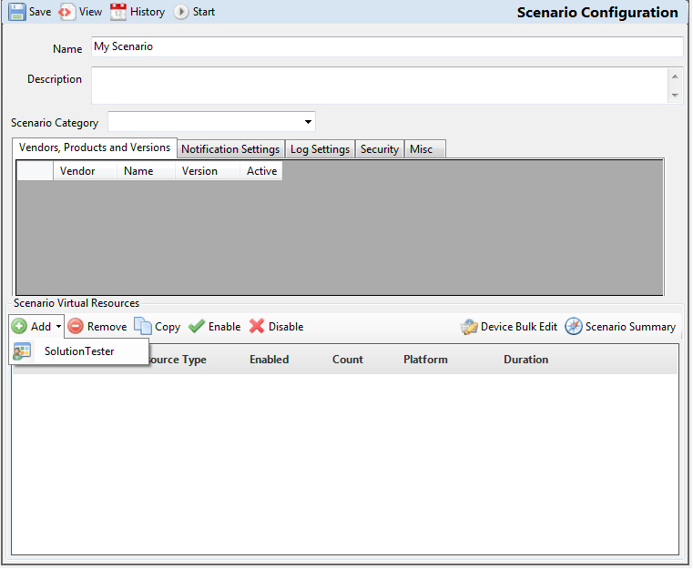

1. From the Solution Tester Configuration screen, select the **Worker Activities** tab. In the **Main Activities** sub-tab, click Add and select **DirtyDevice**.

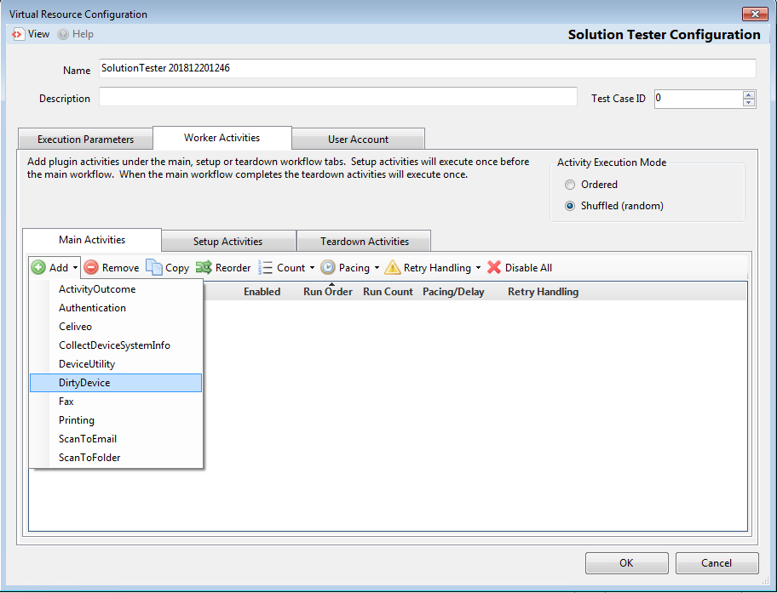

1. Select the desired Plugin Actions and Devices. If Dirty Digital Send is selected, you must configure the Output Folder. This dropdown loads from the Server and Output Monitor configuration explained in the previous two sections.

